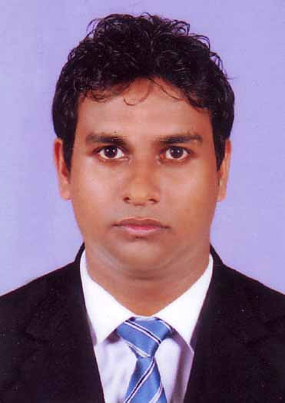

Aruma Handi Susantha Kumara
Samagi Mawatha,
Mahaladuwa,
Balapitiya, Tel: 0778521301,0775911231
Sri Lanka. ahsusantha@yahoo.com

Personal Profile
I am a self driven, team oriented and hardworking person who dare to be different. I am very keen to work in an ever changing dynamic business environment and self motivated to take any challenge. My strengths are inbuilt leadership qualities and ability to take responsibilities. I will constantly challenge myself to exceed expectations and deliver results.

Academic Qualifications
2014  2012  2011 | I am Successfully Completed CAB 2  I am Followed Diploma Level Institution Of Taxation In Sri Lanka  Successfully Completed AAT Final & Intermediate & Foundation  Successfully Completed Computer Course In Computerized Accounting Course at Icm Centre.
2006 | G/Sri Devananda Collage,Ambalangoda.  Passed G.C.E A/L in 2006 in Art subjects
  Sinhala | A
  Buddhist Civilzation | A
  Political Science | C
2003 | G/Randomba kanista Vidiyalaya, Ambalangoda  Passed G.C.E O/L in 2003
  Buddhism | B
  Social Studies | B
  Sinhala | C
  Science & Technology | C
  Agriculture | C
  Health & Ph | B
  Mathematices | S
  English | s

Industry Expierience
Currently, I am Working at the Life Logy (PVT) LTD. Mathugama as a Accountant since 08 Months
I Worked at prime Grameen Micro Finance Ltd As a Branch Accountant Five Years & Six Months

Computer Literacy
- Profound knowledge in MS Office, E-mail & Internet
- Computerized Accounting (Myob,Quick Book, Tally, Accpace)

Soft Skills
- Communication skills
- Leadership qualities
- Team player
- Organizing & Planning

Special Activities

- Member of School sport club.

Personal Details
Date of Birth : 25-10-1987
Sex : Male
Nationality : Sinhalese
Civil Status : Married
N.I.C.No. : 872991824 V
Tel : 0778521301,0775911231
E-mail : ahsusantha@yahoo.com
Interest : Cricket, Reading

Non-Related Referees

Mr M S Andradi ,
The Accountant,
Prime Grameen Micro Finance,
No17 kularathna Road ,
Ambalangoda.
Mr.D M P M Dissanayaka,
The Accountant,
Prime Grameen Micro Finance,
Agalawaththa Road,
Mathugama.

0773675092 0710292697

I hereby declare that the above information given is true and accurate to the best of my knowledge.

Thank You.

……………………………
Susantha Kumara.

